

**7MTT – Oracle 7mode to CDOT Work Instructions**

**Authors:** David Ng

**Contributors:**

**Document Version:** V2

**Date:** April 2015

Status: Published

**CONFIDENTIAL INFORMATION**

This document contains information proprietary to Thomson Reuters and may not be reproduced, disclosed or used in whole or part without express permission of Thomson Reuters.

© Thomson Reuters 2013

Contents

1 Introduction 3

1.1 Management Summary 3

1.2 Change History 3

1.3 Distribution List 3

1.4 Glossary 3

2 7Mode to CDOT Migration 5

2.1 High Level Steps (DB Refresh) 5

2.2 High Level Steps (Migration) 5

2.3 Pre-requisites 6

2.4 Vserver and LIF creation 6

2.4.1 Create Vserver (replace hyphen with underscore in vserver rootvolume name) 6

2.4.2 Create LIF with default route and failover group 6

2.5 DNS configuration 7

2.5.1 Setup DNS on a Vserver 7

2.6 Showmount script user 7

2.7 Oracle account setup 7

2.7.1 Oracle role, user, and SSH publickey configuration (ssh keys are located in DFM server ‘/filers/admin/source/logical’) 7

2.8 NFS and CIFS configuration 8

2.8.1 Enable NFSv3 8

2.9 Start the Migration 8

2.10 Primary job schedule and snapshot policy configuration 26

2.10.1 Create job schedule and snapshot policy (only execute for OraAdmin volume): 26

2.11 Volume creation 26

2.11.1 Create export policies (repeat this step for each volume) 26

2.11.2 Create the default export-policy (repeat this command for every nfs client) 26

2.11.3 Create export policy rule (repeat this command for each volume and nfs client) 26

2.11.4 Add volumes to export & snapshot policies (execute for oraadmin): 26

2.11.5 Add volumes to export & snapshot policies (execute for *ora*_nosnap & *ora*_snap): 26

2.11.6 Delete snapshot policies which were created by 7MTT (names start with ‘SnapShot_*): 27

2.11.7 Rename junction paths (execute for each volume) 27

2.11.8 Setup snap autodelete on volumes (run for each SNAP volume) 27

2.11.9 Create qtrees quotas (repeat command below for each required qtree) 27

2.11.10 Enable the quotas (repeat step for each volume> 27

2.12 QoS policy group creation 27

2.12.1 Create QoS policy group and apply it at the volume level (create one QOS policy for each volume) 27

3 Snapvault Configuration 28

3.1 Cluster and Vserver Peering 28

3.1.1 Confirm that cluster peering has been enabled 28

3.1.2 Create the cluster peer (skip this step if cluster peering has been configured) 28

3.1.3 Confirm if vserver peering has been configured 28

3.1.4 Create vserver peering on the destination system (skip this step if vserver peering has been configured) 28

3.1.5 Accept the vserver peering on the source system 28

3.2 SnapVault configuration 28

There are two data protection configurations for LION: SNAP & NOSNAP. The ‘oradata’ and ‘oraadmin’ volume are vaulted in a SNAP configuration. Only the ‘oraadmin’ volume is vaulted in a NOSNAP configuration. Hence, the number of volumes you execute commands for may vary based on configuration type. 28

3.2.1 Create secondary volumes for SnapVault as type “DP” on the destination cluster 28

3.2.2 Create a cron job schedule if it does not exist in the destination 29

3.2.3 Configure a snapmirror policy on the destination (execute these command for oraadmin & oradata) 29

3.2.1 Initialize SnapVault relationship on the destination (execute these command for oraadmin & oradata) 29

# Introduction

## Management Summary

This document details the process used to migrate an Oracle Database from 7mode to CDOTwith 7MTT.

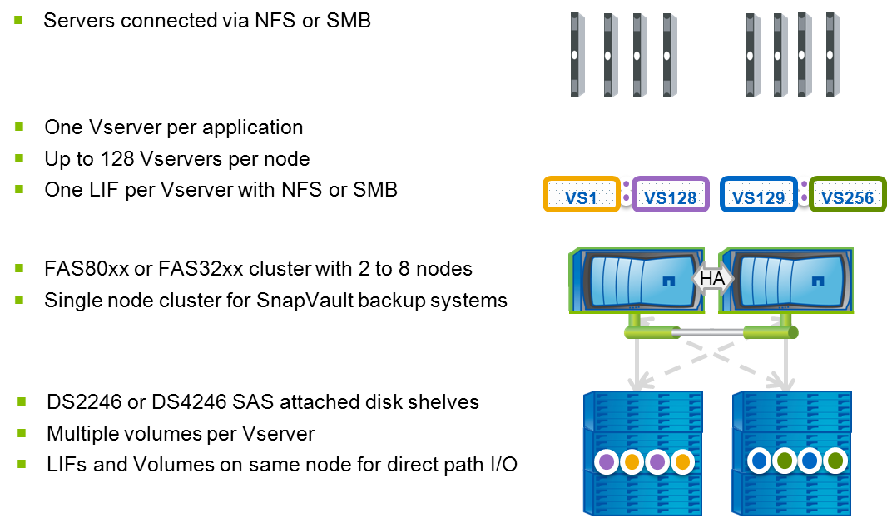

## Change History

|  |  |  |  |
| --- | --- | --- | --- |
| **Ver** | **Date** | **Author** | **Key Changes** |
| 1 | April 2015 | David Ng | Initial Version |

## Distribution List

|  |  |
| --- | --- |
| **Name** | **Role** |
| Storage Support |  |
| Storage Delivery |  |

## Glossary

|  |  |
| --- | --- |
| **Term** | **Definition** |
| cDOT | clustered Data ONTAP |
| Vserver | A logical storage virtual server, also known as a Storage Virtual Machine (SVM), which contains LIFs, Volumes, and configuration information such as access control details. |
| LIF | Logical Interface – a cDOT logical network interface with an IP address, assigned to a single Vserver. |
| 7MTT | 7mode Transition Tool – A tool used to migrate from 7mode to CDOT |
| WFA | OnCommand Workflow Automater – An automation framework application from NetApp, used for storage provisioning. |

# 7Mode to CDOT Migration

## High Level Steps (DB Refresh)

|  |  |
| --- | --- |
| **DB Tech Refresh Steps (7mode to CDOT)** | **Step Owner** |
| Install new database in target system | DBA |
| shut down; save off system, ctl files, etc. as needed on target | DBA |
| unmount s*ora*_snap from target | Unix |
| Create new SVM & volume | Storage |
| initialize replication to existing s*ora*snap volume, or create new s*ora*_snap volume and initialize replication; rename old volume with expiration date | Storage |
| Disable monitoring during maintenance window | Application/DBA |
| Stop Application/Database during maintenance window | Application/DBA |
| Unmount source volumes during maintenance window | Unix |
| Final snapmirror sync/break during maintenance window | Storage |
| Update '/etc/fstab' during maintenance window | Unix |
| Mount new volumes during maintenance window | Unix |
| Restore Database, move system, ctl, etc files into place during maintenance window | DBA |
| Follow standard TTS import of tablespaces that were mirrored over during maintenance window | DBA |
| Start DB during maintenance window | DBA |
| Reboot Server & verify environment during maintenance window | Unix/DBA |

## High Level Steps (Migration)

|  |  |
| --- | --- |
| **DB Migration Steps (7mode to CDOT)** | **Step Owner** |
| Create SVM & volumes | Storage |
| Initialize volume replication before maintenance window | Storage |
| Disable monitoring during maintenance window | Application/DBA |
| Stop Application/Database during maintenance window | Application/DBA |
| Unmount source volumes during maintenance window | Unix |
| Final snapmirror sync/break during maintenance window | Storage |
| Update '/etc/fstab' during maintenance window | Unix |
| Mount new volumes during maintenance window | Unix |
| Start DB and verify no file read/write errors during maintenance window | DBA |
| Reboot Server & verify environment during maintenance window | Unix/DBA |

## Pre-requisites

* Confirm the target aggregate has sufficient capacity
* Confirm the source volume is 64 bit
* Register the target vserver hostname in DNS
* Make note of service accounts on the source so they can be created in destination
* Confirm there is network connectivity between the source and target
* Add the CDOT vserver name (not IP) to the source systems /etc/snapmirror.allow file
* Make note of qtree quotas sizes so they can be applied in destination
* Make note of the source volume language
* Make note of the backup volume size

## ****Vserver and LIF creation****

### Create Vserver (replace hyphen with underscore in vserver rootvolume name)

vserver create -vserver <vsname> -rootvolume <vsname>_root -aggregate <aggrname> -ns-switch file -nm-switch file -rootvolume-security-style unix -language <language>

vserver show

### Create LIF with default route and failover group

network interface create -vserver <vsname> -lif <vsname>-lif-<lif#> -role data -data-protocol nfs -home-node <node> -home-port <port> -address <ip> -netmask <netmask> -status-admin up -firewall-policy mgmt -failover-group <group>

network routing-groups route create -vserver <vsname> -routing-group d<network>/<mask> -destination 0.0.0.0/0 -gateway <gateway>

vserver show

network interface show

network interface show -failover

network routing-groups route show –vserver <vsname>

## ****DNS configuration****

### Setup DNS on a Vserver

vserver services dns create -vserver <vsname> -domains <domainname> -name-servers <comma_separate_name_server_list>

vserver services dns show

## Showmount script user

security login role create -role showmount -cmddirname "vserver export-policy" -access readonly -vserver <vserver>

security login role create -role showmount -cmddirname volume -access readonly -vserver <vserver>

security login role create -role showmount -cmddirname "version" -access all -vserver <vsname>

security login create -username shwmnt -application ontapi -authmethod password -role showmount -vserver <vserver>

## ****Oracle account setup****

### Oracle role, user, and SSH publickey configuration (ssh keys are located in DFM server ‘/filers/admin/source/logical’)

security login role create -role oracle -cmddirname "volume snapshot" -access all -vserver <vsname>

security login role create -role oracle -cmddirname "set" -access all -vserver <vsname>

security login role create -role oracle -cmddirname "version" -access all -vserver <vsname>

security login role create -role oracle -cmddirname "job show" -access readonly -vserver <vsname>

security login role create -role oracle -cmddirname "df" -access readonly -vserver <vsname>

security login role create -role oracle -cmddirname "snapmirror list-destinations" -access readonly –vserver <vsname>

security login create -username oracle -application ssh -authmethod publickey -role oracle -vserver <vsname>

security login publickey create -username oracle -vserver <vsname> -publickey "<ssh-dss pub_key_string>"

## ****NFS and CIFS configuration****

### Enable NFSv3

vserver nfs create -vserver <vsname> -access true -v3 enabled

vserver nfs show

## ****Start the Migration****

Connect the 7MTT (https://<7MTT_Server>:8443/transition) tool via web browser

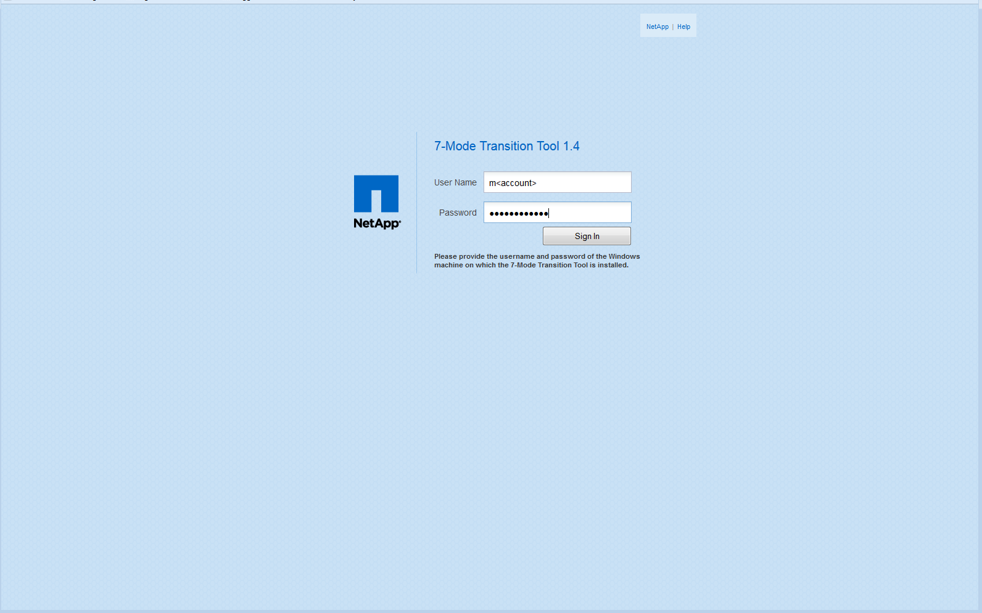

* Click ‘Migrate’

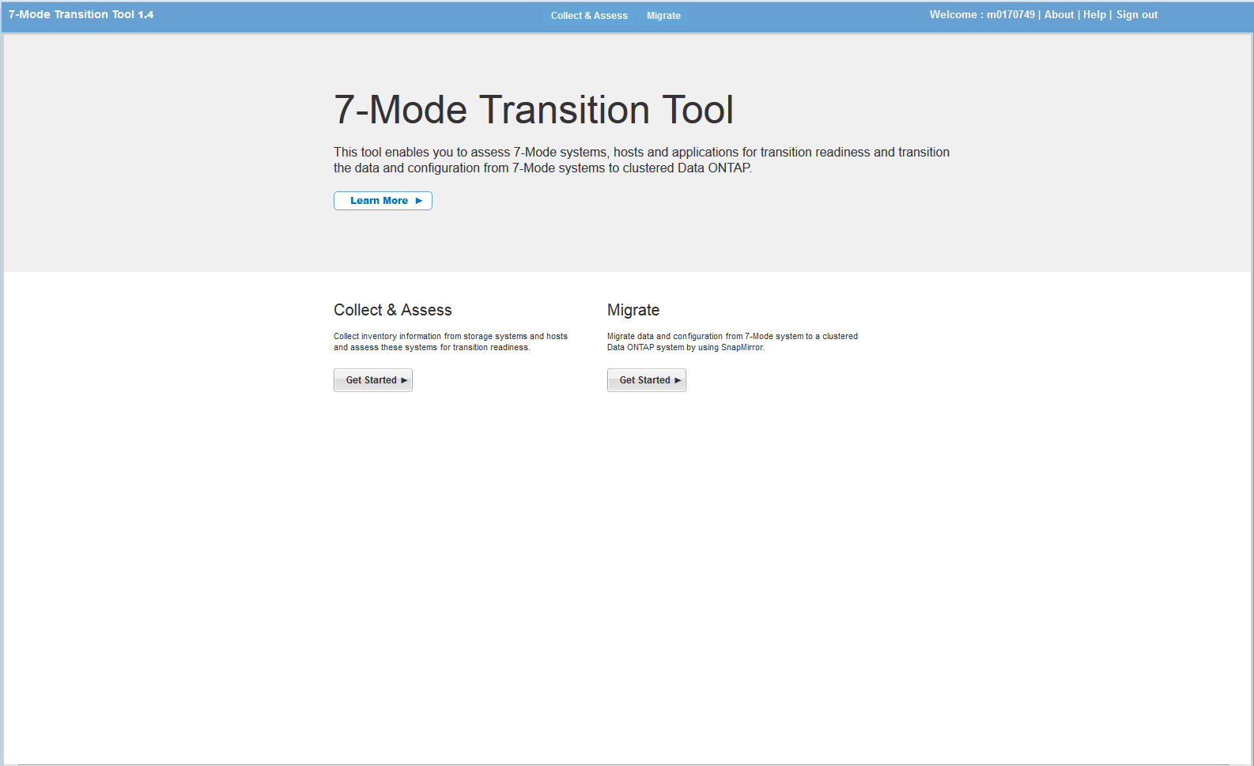

CLICK on the ‘Storage System’ button in the left pane:

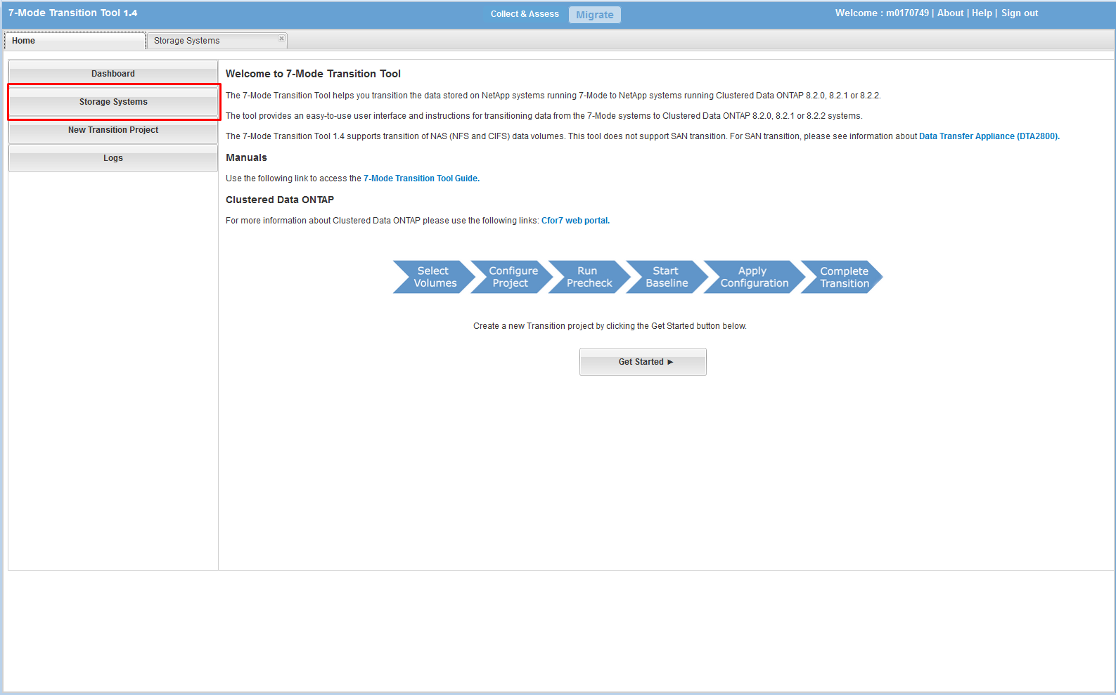

* Add storage systems to 7MTT (execute this step for the source and target storage systems):
* ENTER the FQDN of the filer
* CLICK ADD

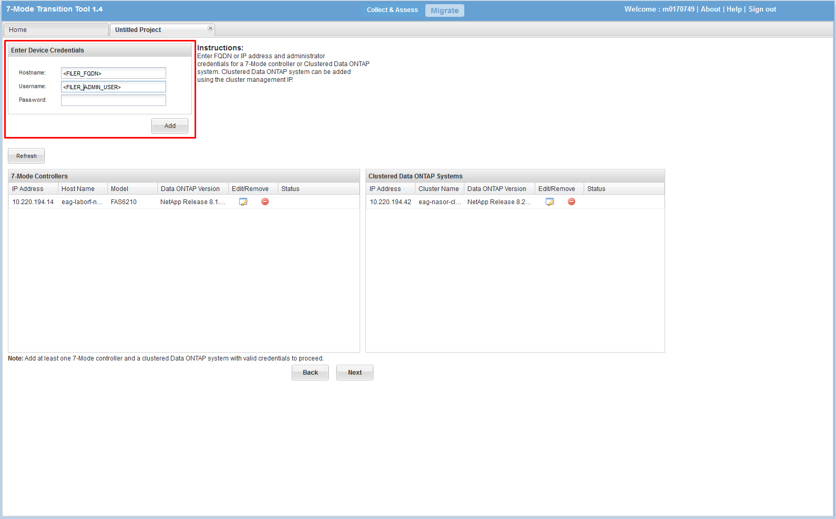

* CLICK the ‘HOME’ tab -> CLICK ‘Ge Started’

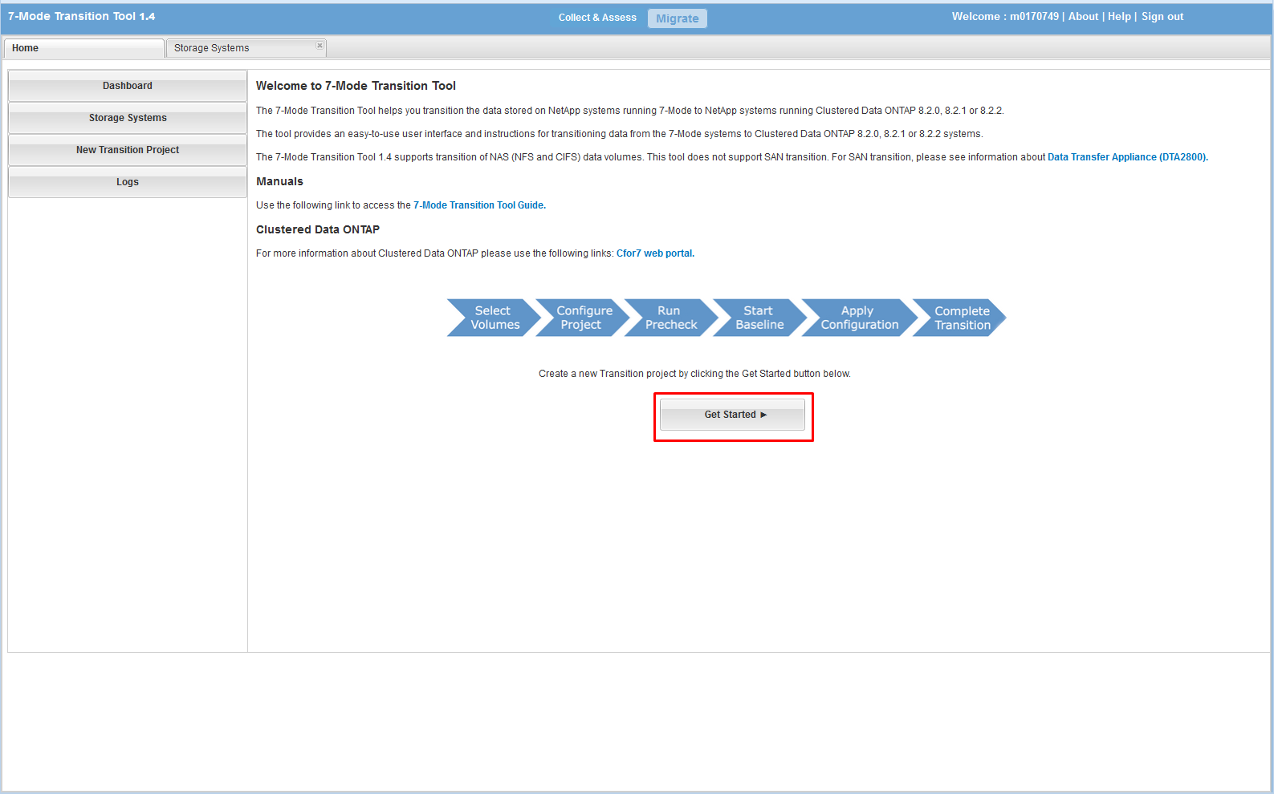

* Confirm that the source and destination storage systems are listed
* CLICK ‘Next’

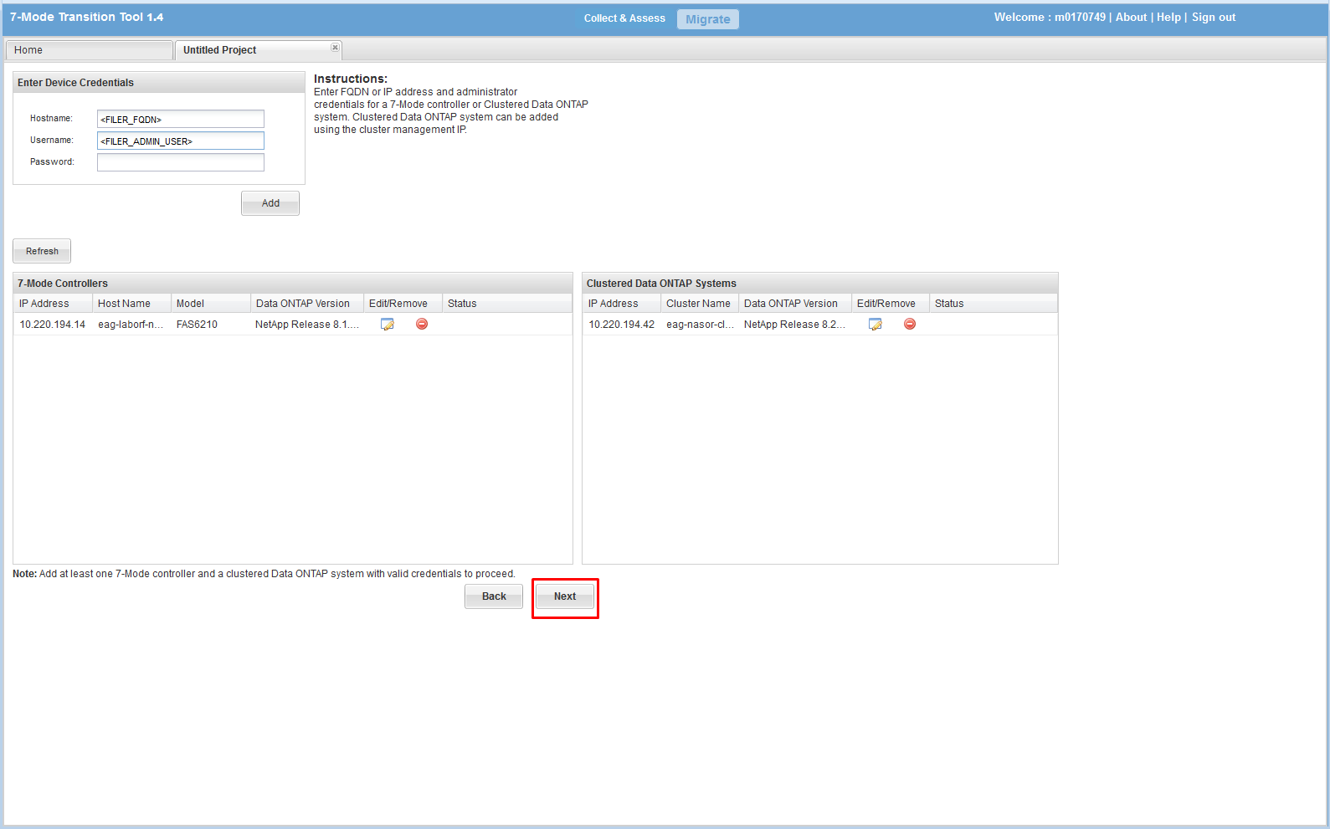

* ENTER a name for the project
* CLICK ‘Continue’

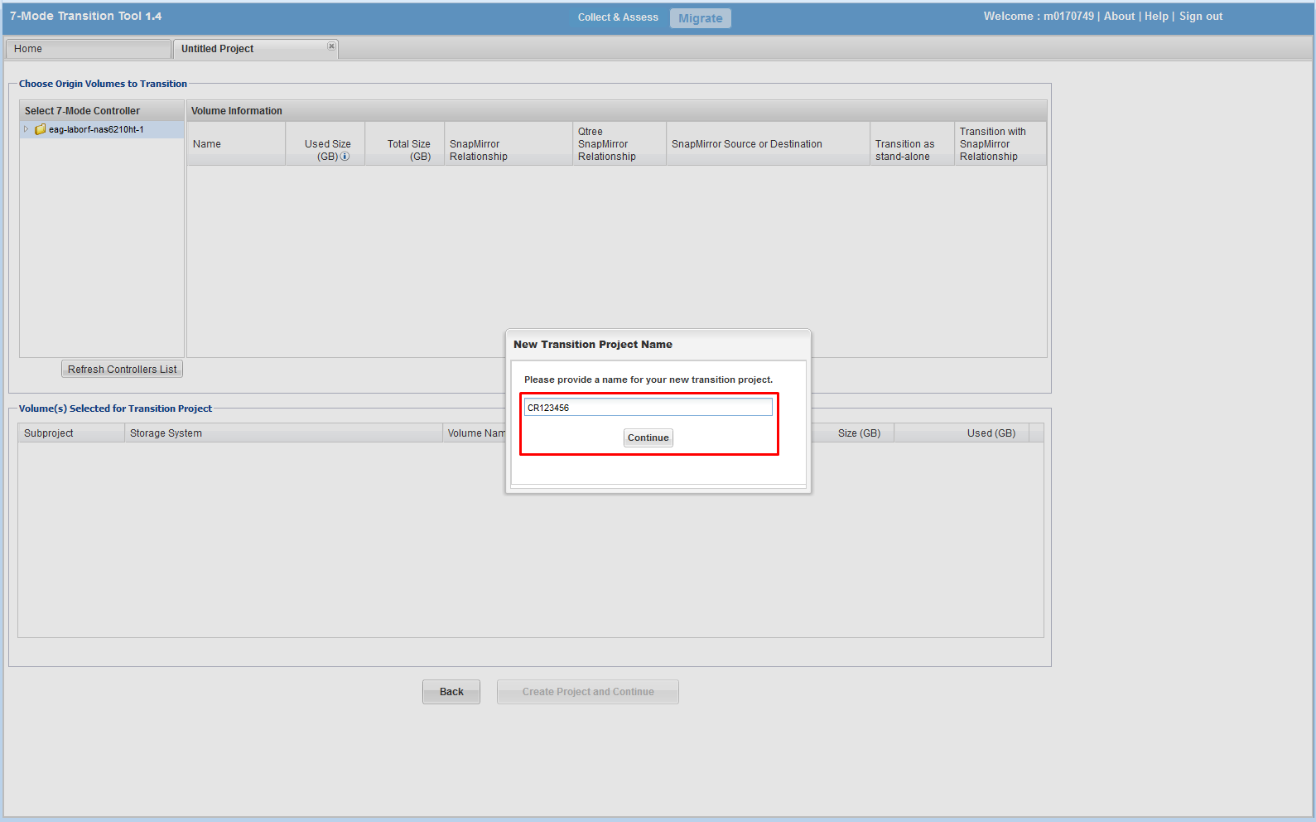

* SELECT the source vfiler and volume(s):
* CLICK ‘Create Project and Continue’

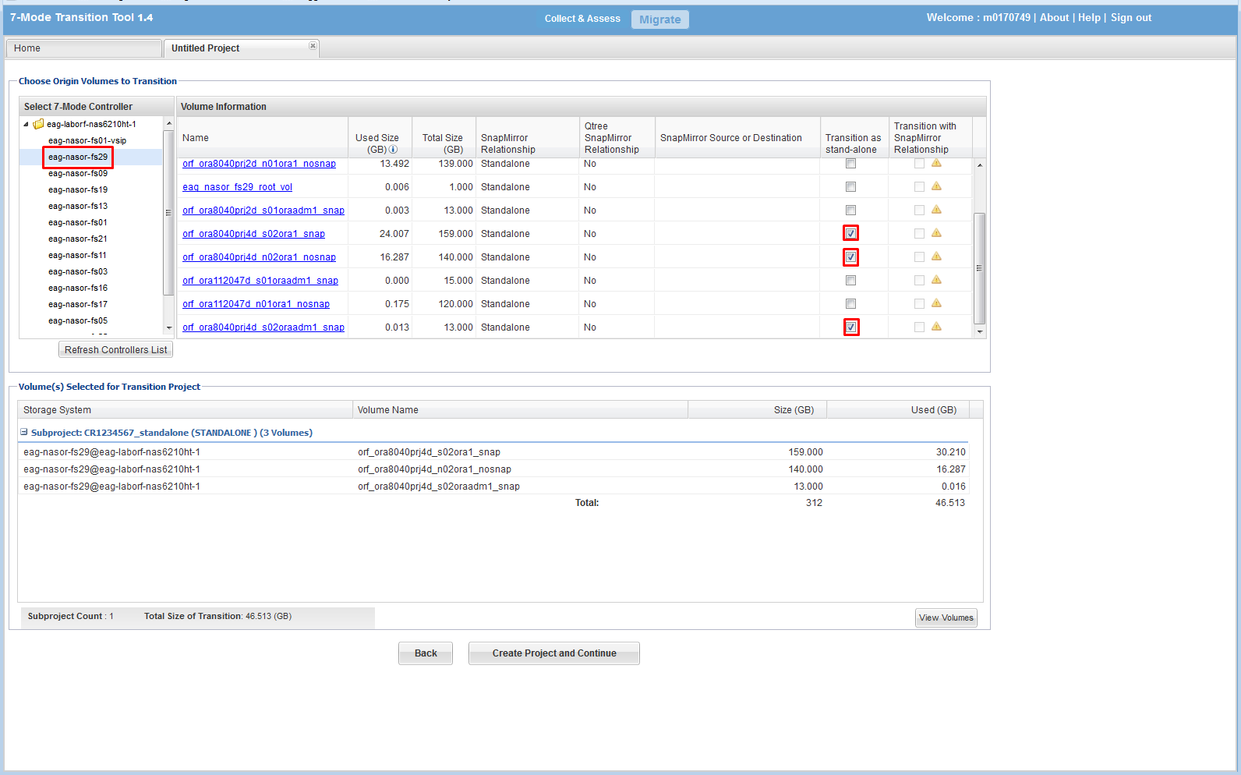

* ENTER an IP to be used for replication traffic on the source filer
* CLICK ‘Next’

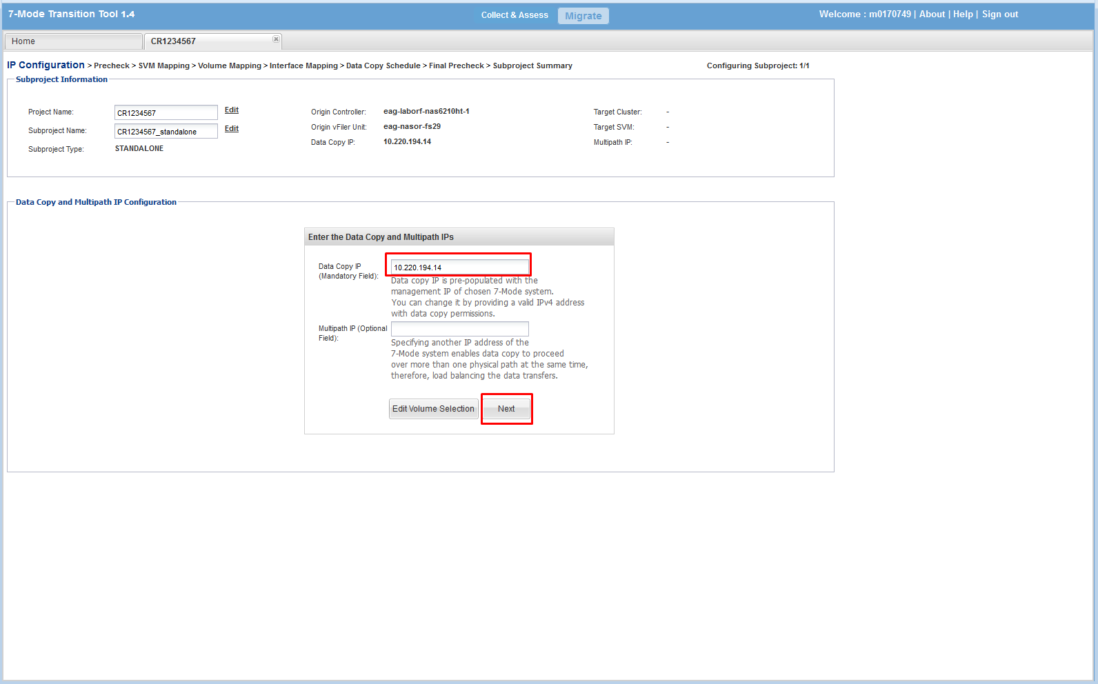

* The next window will ask if you want to run pre-check
* CLICK ‘Run Prechecks’

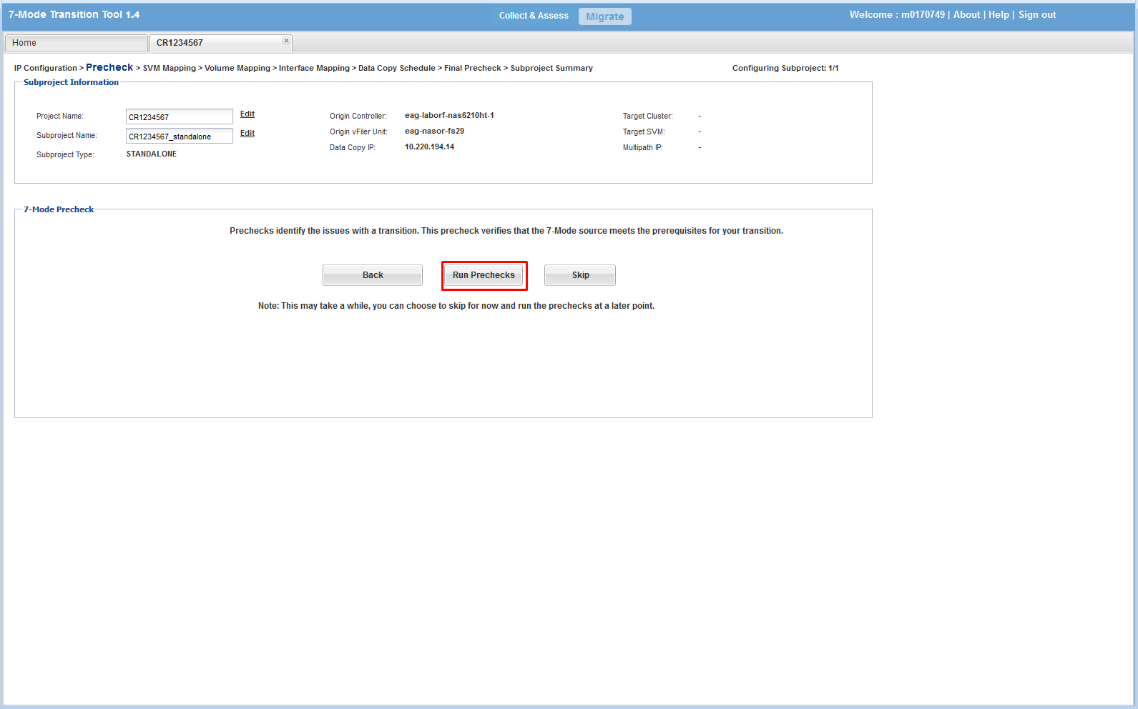

* Review the Report. You can ignore the warnings listed below. Resolve errors if they appear.
* CLICK ‘Close’
* CLICK ‘Next’

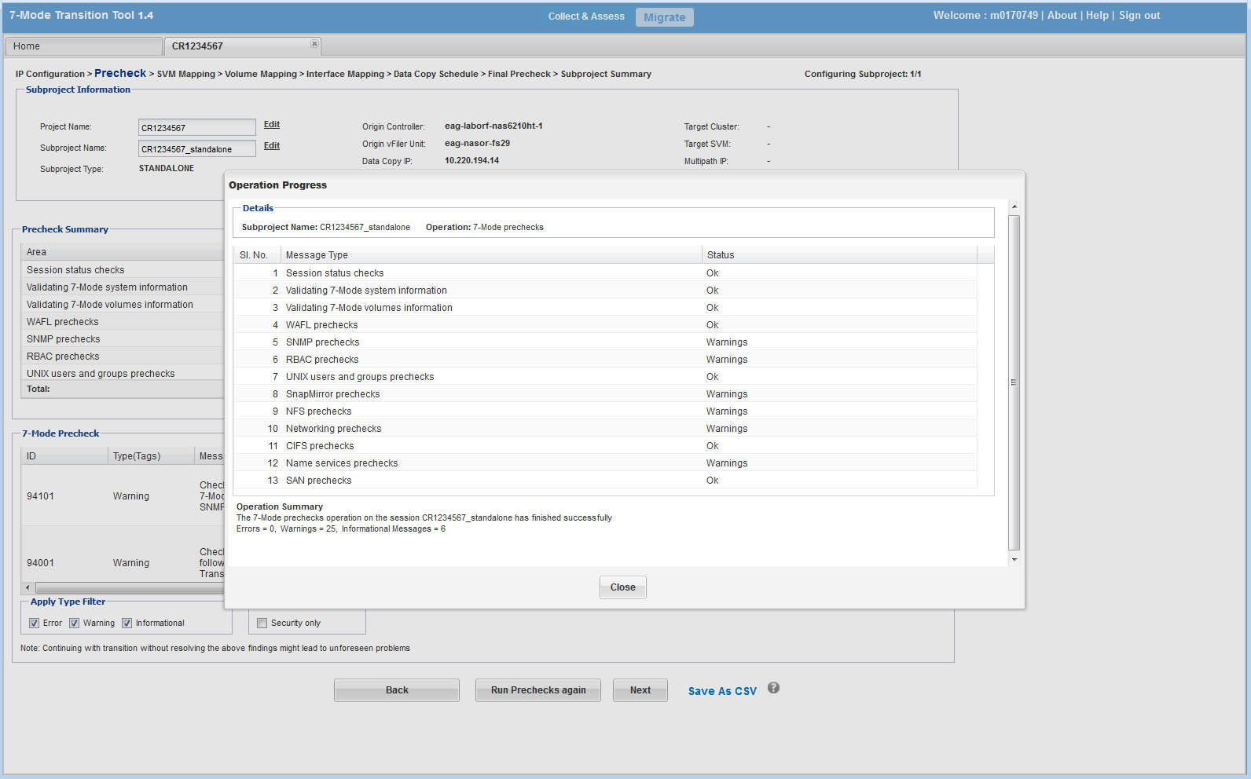

* SELECT a target vserver
* CLICK ‘Next’

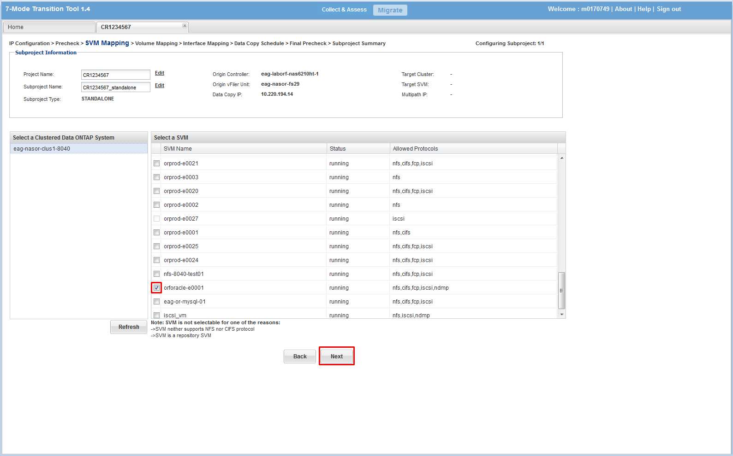

**IMPORTANT: Make sure you enter the correct information in this section! Newer versions of 7MTT allow you to set junction path = volume name, this is the DCO standard. But, you need to modify the junction-path after the cut-over manually in older versions of 7MTT.**

* ENTER the destination aggregate
* ENTER the destination volume name
* SELECT ‘Use Clustered OTAP volume name’ from ‘Target Volume Mount Policy’ if drop down menu is available
* CLICK ‘Next’

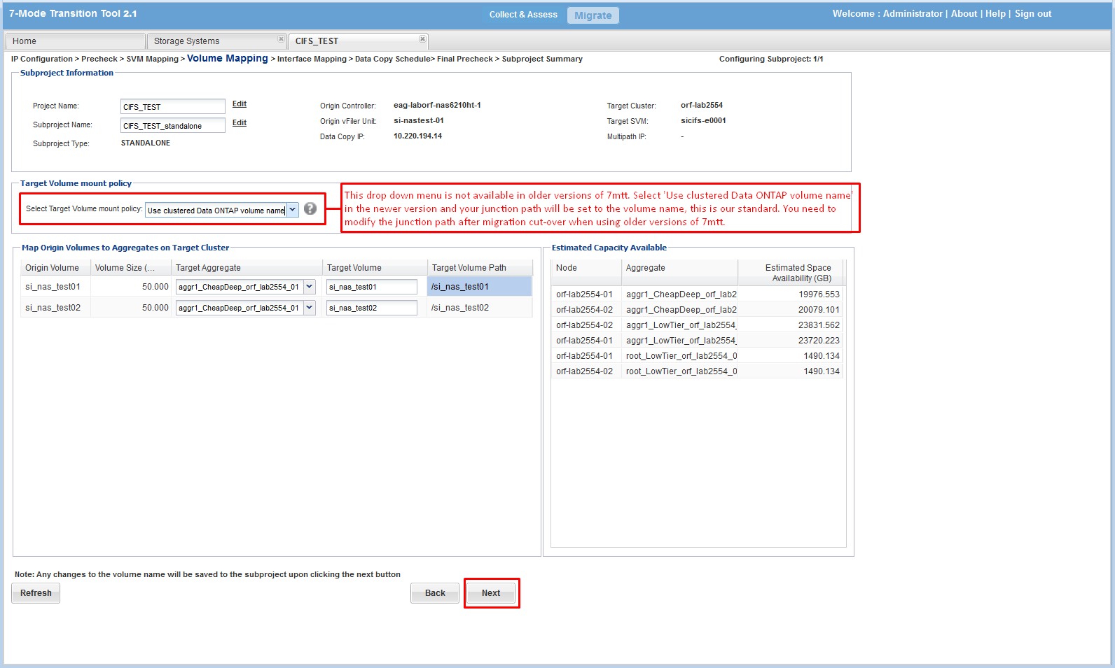

NOTE: We are not migrating IP addresses

* CLICK ‘Next’

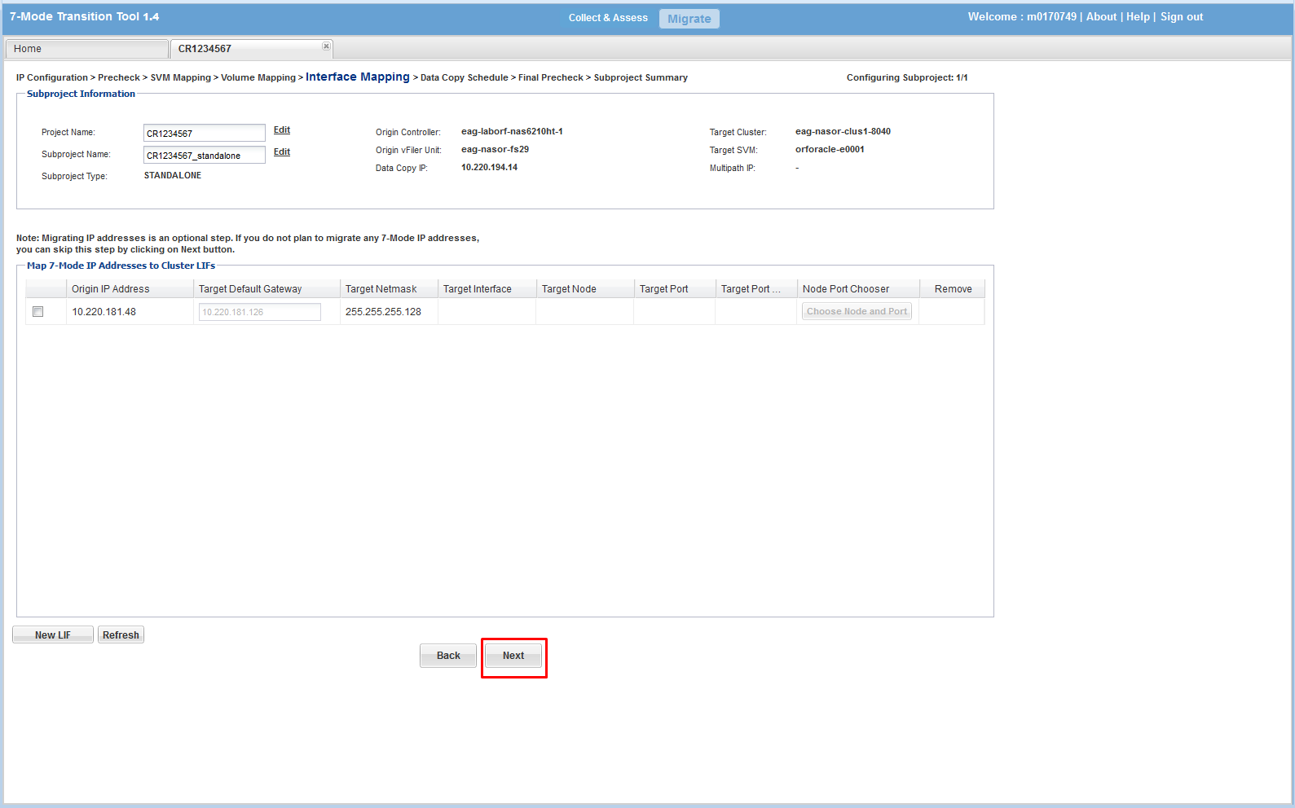

* CLICK ‘Create Schedule’, a popup box will appear
* ENTER a replication schedule (run off hours)
* CLICK CREATE

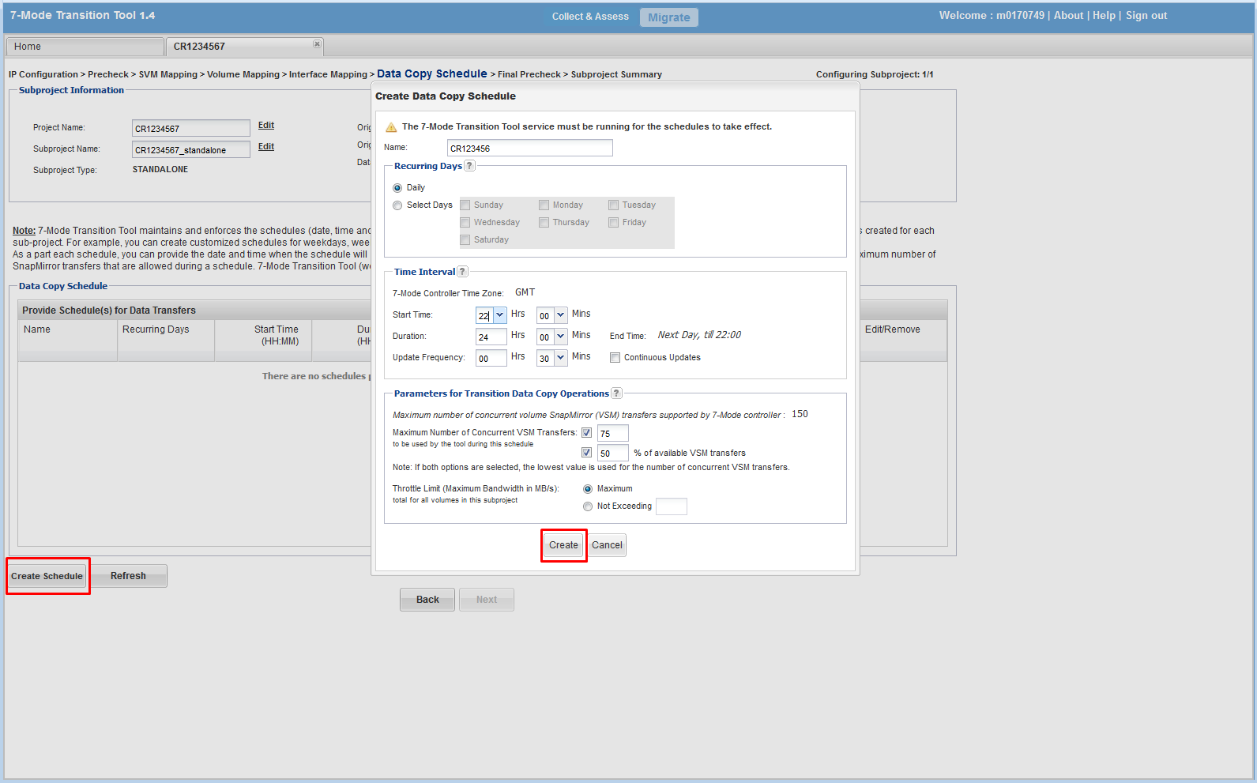

* The newly created schedule will appear
* CLICK ‘Next’

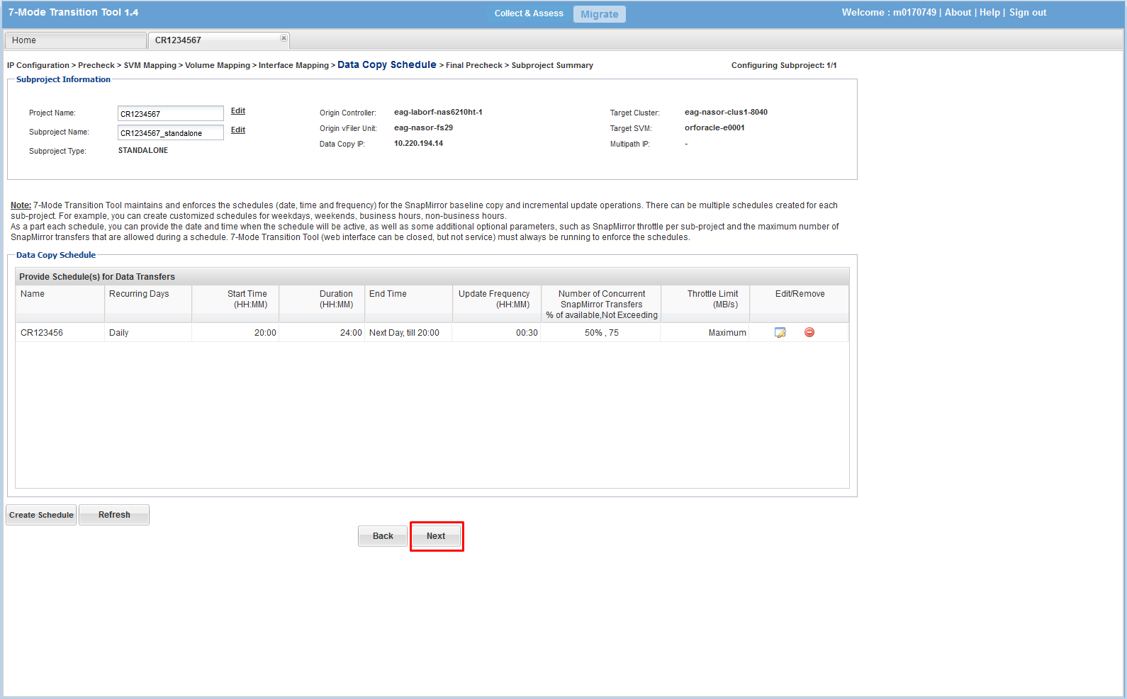

* Run PreCheck and make sure there are no errors
* CLICK ‘Run Precheck’; REVIEW the output
* CLICK ‘Close’
* CLICK ‘Next’

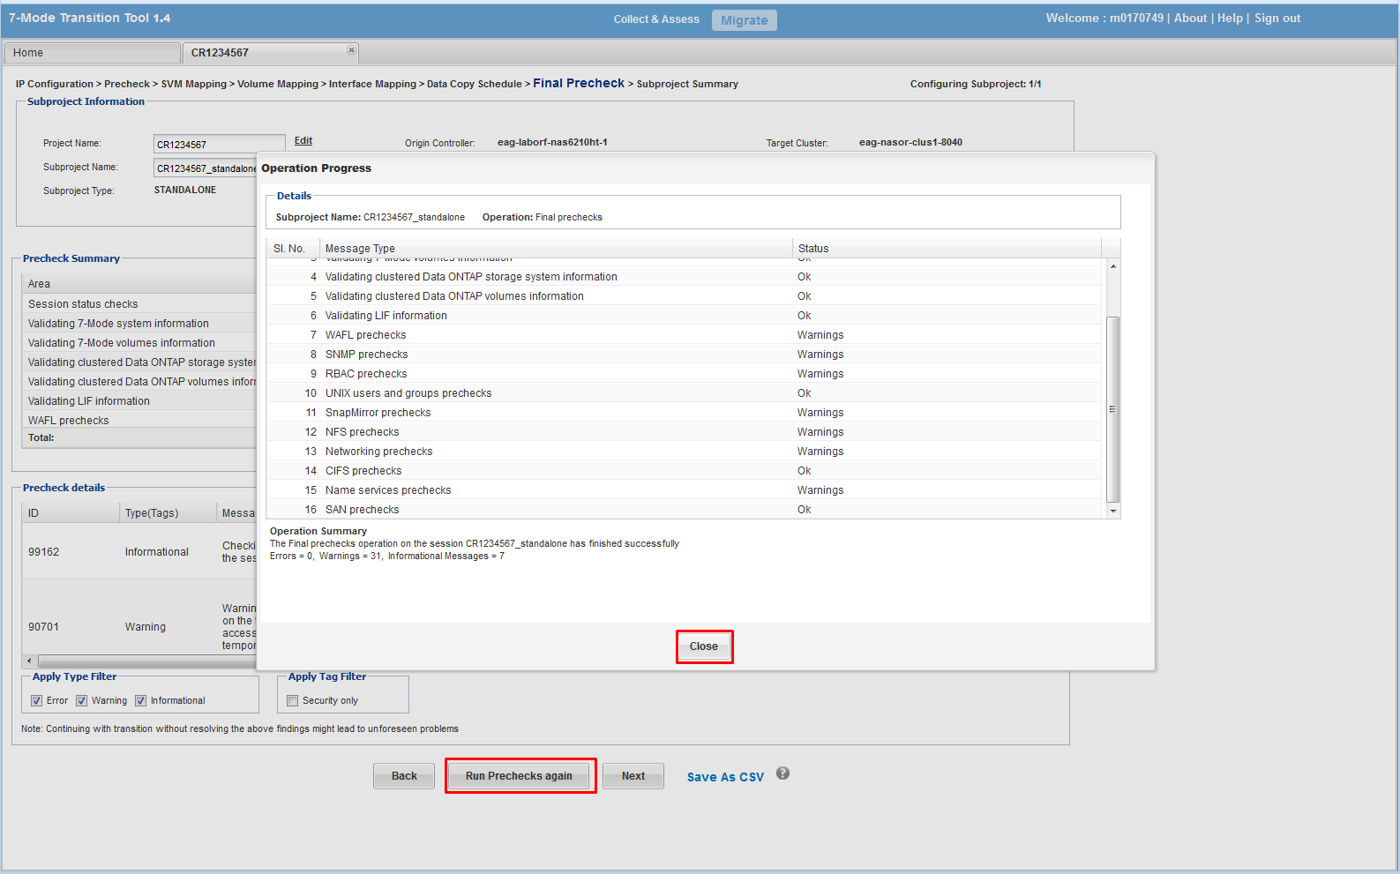

* Review the output
* CLICK ‘Save and go to Dashboard’

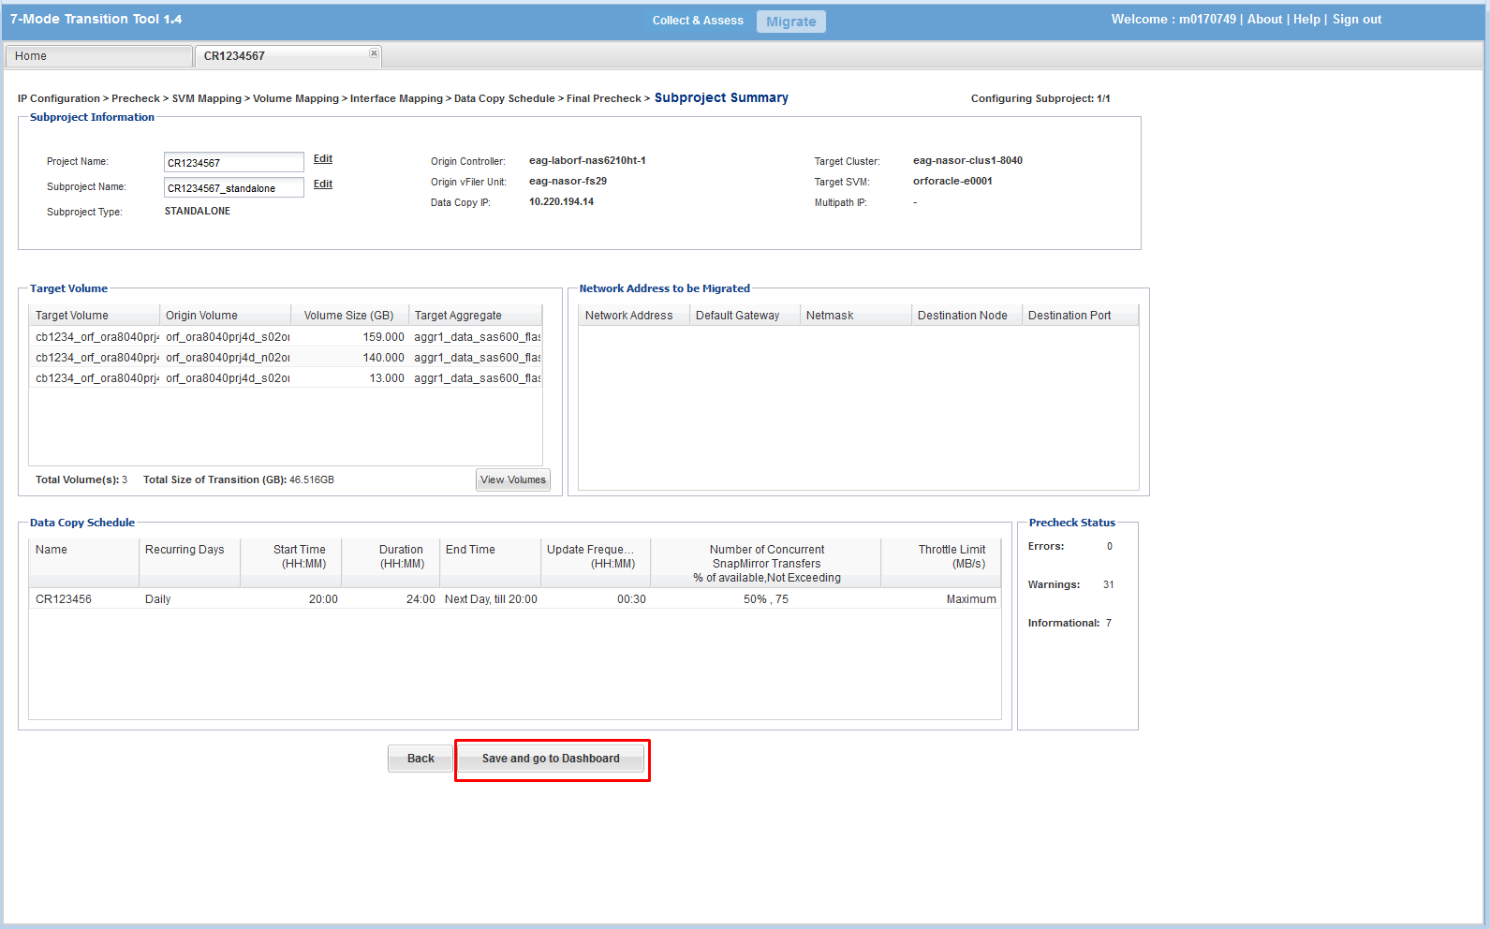

* A data transfer workflow will be displayed in the top of the page. The circle above ‘Baseline Data Copy’ will have a white fill color before your first transfer. It will have an orange fill color while the first transfer is running. Then a green fill color after your first successful transfer.
* CLICK ‘Run Pre-Check’; REVIEW output
* CLICK ‘Start Baseline’
* A popup window will appear, CLICK ‘yes’

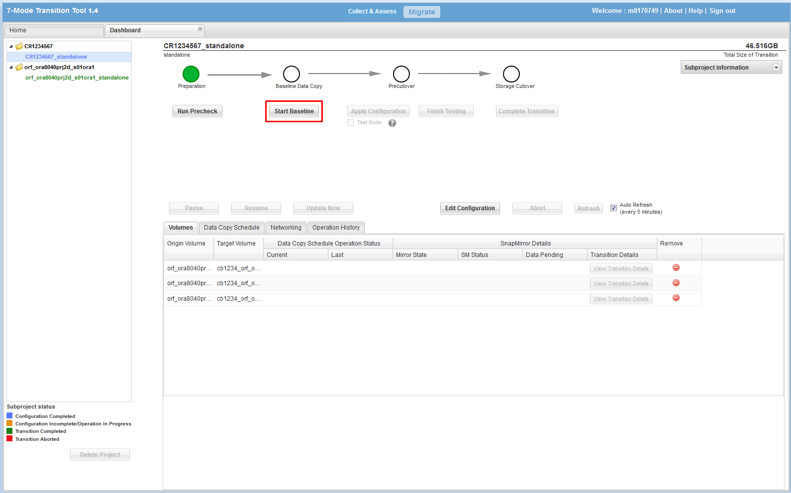

* Execute an update transfer before the cutover window so that you have minimal changes to transfer during the cutover window:
* CLICK ‘Update Now’

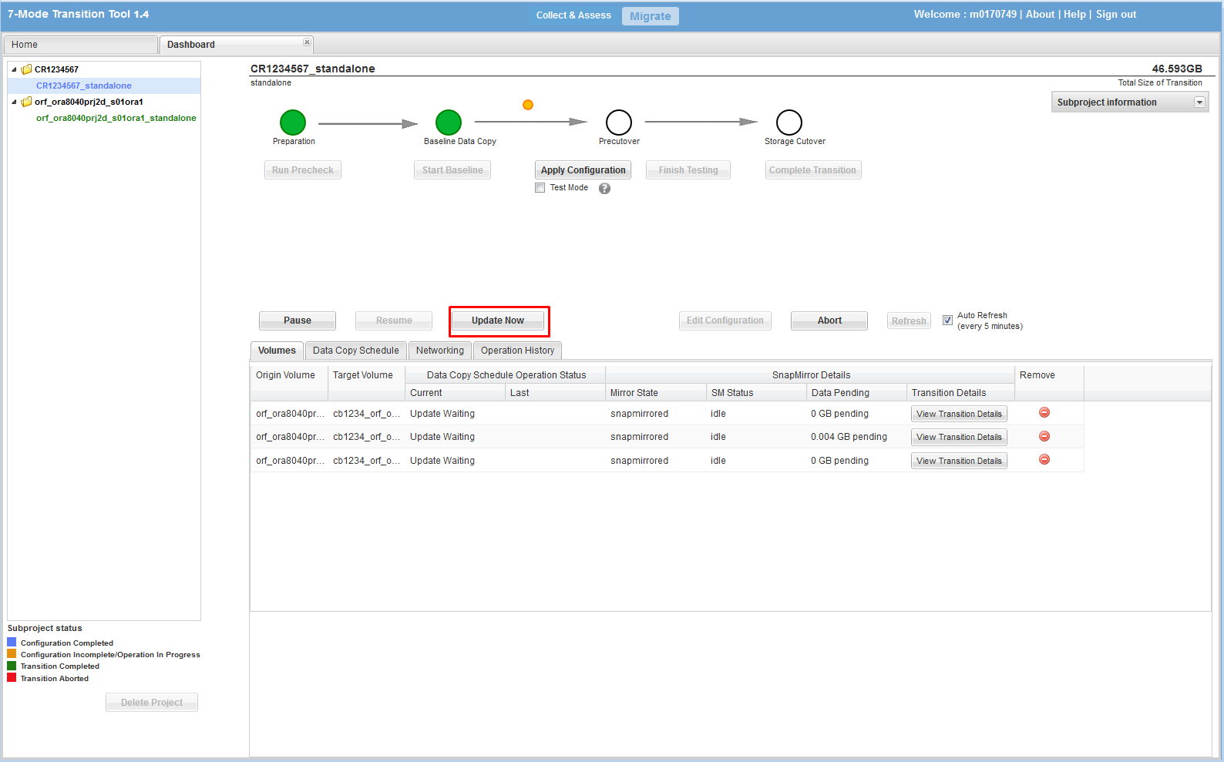

Ensure the steps below are completed during the downtime window before proceeding:

* The database has been shut down
* Source volumes have been unmounted
  + Start the cutover process:
  + CLICK ‘Apply Configuration’
  + A popup box will appear, CLICK ‘Continue’

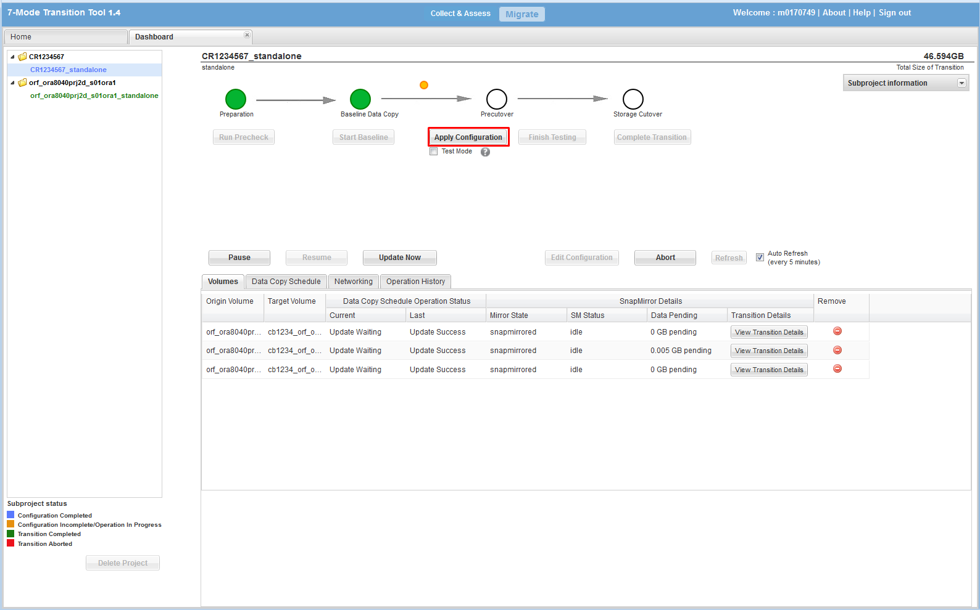

* Review log for errors
* CLICK ‘Close’

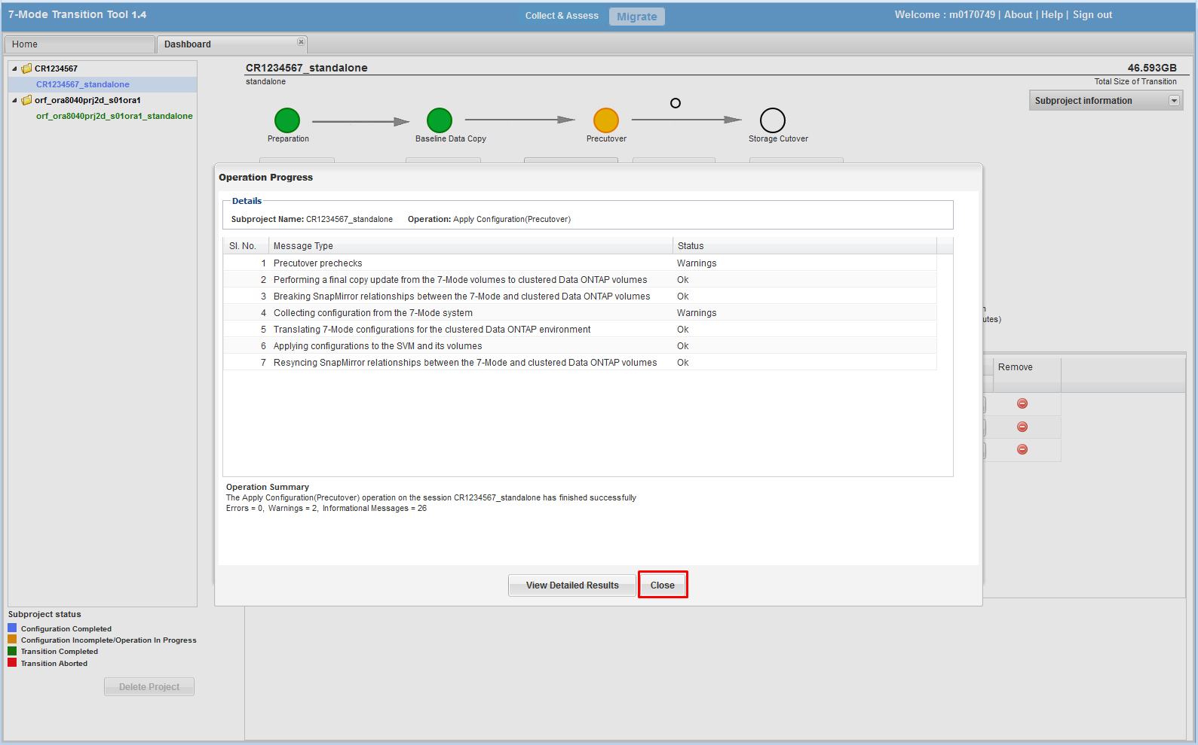

* CLICK ‘Complete Transition’
* A popup box will appear, CLICK ‘yes’
* A popup box will appear stating that the source volume will be made offline, CLICK ‘Continue’

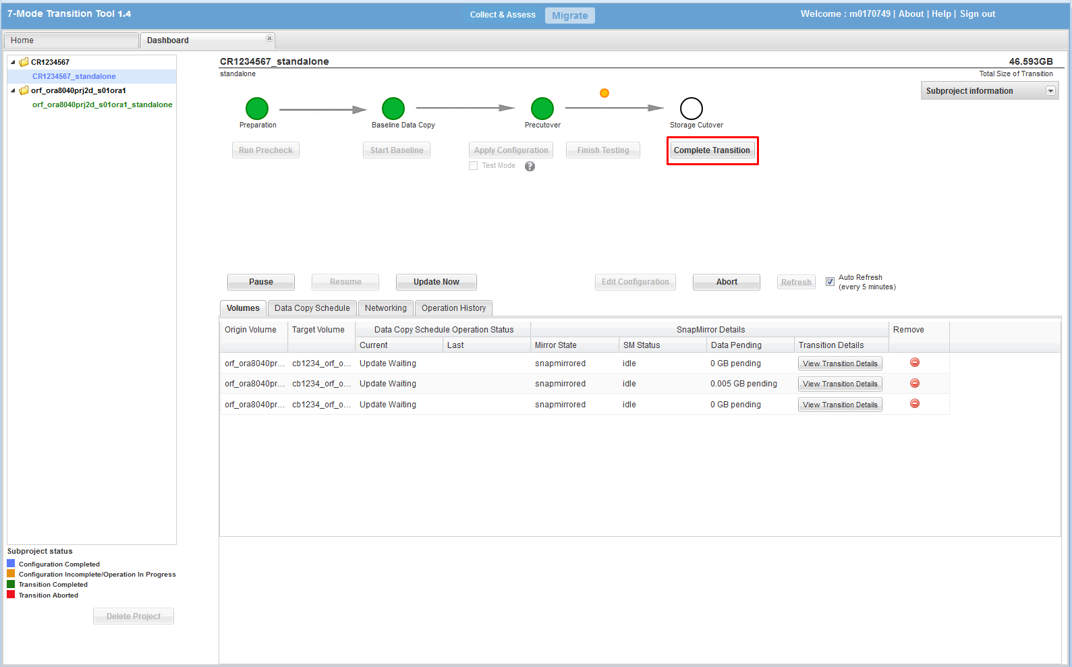

* Review the log output for a successful transition
* CLICK ‘Close’

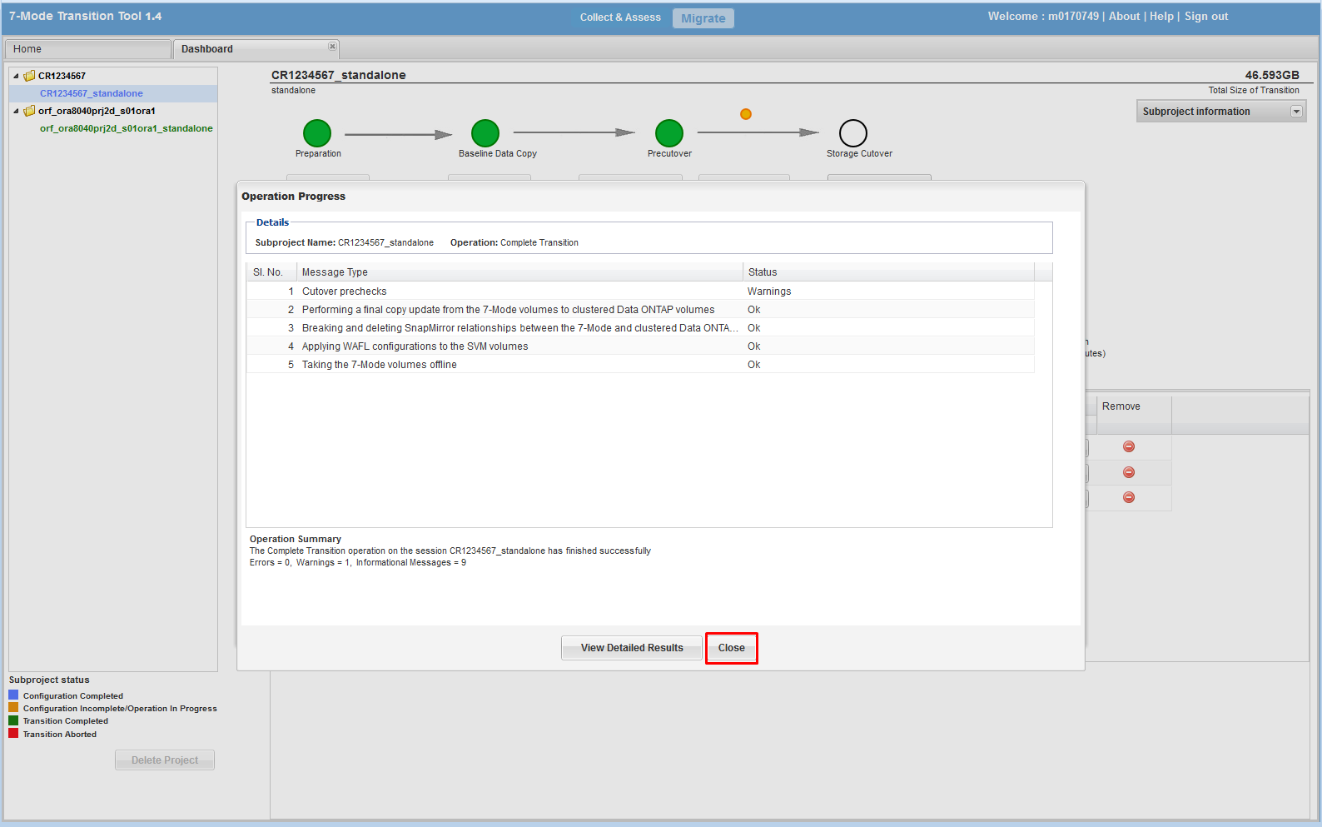

## ****Primary job schedule and snapshot policy configuration****

### Create job schedule and snapshot policy (only execute for OraAdmin volume):

job schedule cron create -name <volume_name> -minute <min> -hour <hour>

volume snapshot policy create -vserver <vsname> -policy <volume_name> -enabled true -schedule1 <volume_name> -count1 7 -snapmirror-label1 snapvault -prefix1 sv_<volume_name>

job schedule cron show -name <vol_name>

volume snapshot policy show –vserver <vsname>

## ****Volume creation****

### Create export policies (repeat this step for each volume)

vserver export-policy create –vserver <vsname> –policyname <volume_name>

### Create the default export-policy (repeat this command for every nfs client)

vserver export-policy rule create -vserver <vsname> -policyname default

-clientmatch <nfsclient> -rorule sys -rwrule sys -superuser sys

### Create export policy rule (repeat this command for each volume and nfs client)

vserver export-policy rule create -vserver <vsname> -policyname <volume_name> -clientmatch <nfsclient> -rorule sys -rwrule sys -superuser sys

### Add volumes to export & snapshot policies (execute for oraadmin):

volume modify -volume <volume_name> -policy <volume_name> -snapshot-policy <volume_name> -vserver <vserver>

### Add volumes to export & snapshot policies (execute for *ora*_nosnap & *ora*_snap):

volume modify -volume <volume_name> -policy <volume_name> -snapshot-policy none -vserver <vserver>

volume show -vserver <vsname>

vserver export-policy rule show

### Delete snapshot policies which were created by 7MTT (names start with ‘SnapShot_*):

snapshot policy show -vserver <vserver>

snapshot policy delete -vserver <vserver> -policy <policy_name>

### Rename junction paths (execute for each volume)

volume unmount -vserver <vserver> -volume <volume_name>

volume mount -vserver <vserver> -volume <volume_name> -junction-path /<volume_name>

volume show -vserver <vserver> -junction

### Setup snap autodelete on volumes (run for each SNAP volume)

volume modify -vserver <vsname> -volume <volname> -space-mgmt-try-first snap_delete

volume snapshot autodelete modify -vserver <vsname> -volume <vol_name> -enabled true

volume snapshot autodelete modify -vserver <vsname> -volume <vol_name> -trigger snap_reserve

volume snapshot autodelete show -vserver <vsname>

volume show -vserver <vsname> -fields space-mgmt-try-first

volume snapshot autodelete show -vserver <vsname>

### Create qtrees quotas (repeat command below for each required qtree)

volume quota policy rule create -vserver <vsname> -policy-name default -volume <nosnap_volname> -type tree -target <qtname> -disk-limit <XXXg>

### Enable the quotas (repeat step for each volume>

volume quota on -vserver <vsname> -volume <volname>

## ****QoS policy group creation****

### Create QoS policy group and apply it at the volume level (create one QOS policy for each volume)

qos policy-group create -policy-group <volname> -vserver <vsname> -max-throughput 6000iops

volume modify -vserver <vsname> -volume <volume> -qos-policy-group <volname>

qos policy-group show

volume show –vserver <vsname> -fields qos-policy-group

# Snapvault Configuration

## Cluster and Vserver Peering

### Confirm that cluster peering has been enabled

cluster peer show

### Create the cluster peer (skip this step if cluster peering has been configured)

cluster peer create -peer-addrs <remote_ICL_IP1,remote_ICL_IP2> -username admin

cluster peer show

### Confirm if vserver peering has been configured

vserver peer show

### Create vserver peering on the destination system (skip this step if vserver peering has been configured)

vserver peer create -vserver <destination_vserver> -peer-cluster <source_cluster> -peer-vserver <source_vserver> -applications snapmirror

vserver peer show

### Accept the vserver peering on the source system

vserver peer accept -vserver <source_vserver> -peer-vserver <destination_vserver>

vserver peer show

## SnapVault configuration

### There are two data protection configurations for LION: SNAP & NOSNAP. The ‘oradata’ and ‘oraadmin’ volume are vaulted in a SNAP configuration. Only the ‘oraadmin’ volume is vaulted in a NOSNAP configuration. Hence, the number of volumes you execute commands for may vary based on configuration type.

### Create secondary volumes for SnapVault as type “DP” on the destination cluster

volume create -vserver <vserver> -volume <volume_name> -aggregate <aggr_name> -size <size> -security-style unix -space-guarantee none -percent-snapshot-space 0 -language <vol_language> -type DP

volume show

### Create a cron job schedule if it does not exist in the destination

job schedule cron create -name xdp_<hour> -minute 00 -hour <hour>

job schedule show

### Configure a snapmirror policy on the destination (execute these command for oraadmin & oradata)

* **7 day retention will have a snapshot count of 14 on the secondary**
* **14 day retention will have a snapshot count of 28 on the secondary**
* **30 day retention will have a snapshot count of 60 on the secondary**
* **45 day retention will have a snapshot count of 90 on the secondary**

snapmirror policy create -vserver <vserver> -policy <volume>

snapmirror policy add-rule -vserver <vserver> -policy <volume> -snapmirror-label snapvault -keep <retention#>

snapmirror show -destination-path * -fields Schedule

snapmirror policy show

### Initialize SnapVault relationship on the destination (execute these command for oraadmin & oradata)

snapmirror create -source-path <source_vserver>:<source_volume> -destination-path <destination_vserver>:<destination_volume> -type XDP -schedule <schedule_name> -policy <policy_name>

snapmirror initialize -destination-path <destination_vserver>:<destination_volume>

snapmirror show